Software Requirements Specification
for
Intel 8085 Online Simulator
Version 0.1
Prepared by Ayush Kashyap
MNIT Jaipur
15/1/2022
Table of Contents
Table of Contents ii
Revision History ii
1. Introduction 1
1.1 Purpose 1
1.2 Document Conventions 1
1.3 Intended Audience and Reading Suggestions 1
1.4 Product Scope 1
1.5 References 1
2. Overall Description 2
2.1 Product Perspective 2
2.2 Product Functions 2
2.3 User Classes and Characteristics 2
2.4 Operating Environment 2
2.5 Design and Implementation Constraints 2
2.6 User Documentation 3
2.7 Assumptions and Dependencies 3
3. External Interface Requirements 3
3.1 User Interfaces 3
3.2 Hardware Interfaces 8
3.3 Software Interfaces 8
3.4 Communications Interfaces 8
4. System Features 8
4.1 Modern Editor 8
4.2 Inspect Memory And Register Status 8
4.3 Assembler 8
4.4 Runner 8
4.5 Debugger 8
5. Other Nonfunctional Requirements 9
5.1 Performance Requirements 9
5.2 Safety Requirements 9
5.3 Security Requirements 9
5.4 Software Quality Attributes 9
6. Other Requirements 9
Appendix A: Glossary 9

Revision History
Name | Date | Reason For Changes | Version

Introduction

Purpose
The purpose of this document is to present a detailed description of the Intel 8085 online simulator software. It will explain the purpose and features of the software, the
interfaces of the software, what the software will do and the constraints under which
it must operate. This document is intended for users of the software and developers.

Document Conventions
This Document was created based on the IEEE template for System Requirement
Specification Documents.

Intended Audience and Reading Suggestions
- Typical Users, such as students, who want to use Simulator to understand the working of 8085 microprocessor and gain some experience in writing the assembly language.
•
- Programmers who are interested in working on the project by further developing it
or fix existing bugs.

Product Scope
This simulator is a tool that people can use to study Intel 8085 MP and learn assembly. Users can use it write the scripts against the simulator and run it. They can view the exact changes for the memory, registers and flags. They can debug it using step by step.

References
- Simulator Source: https://github.com/ayushk7/simsim85

- Wikipedia: https://www.google.com/url?sa=t&rct=j&q=&esrc=s&source=web&cd=&cad=rja&uact=8&ved=2ahUKEwiAn6Gk1tH1AhXP7XMBHQNiAP8QFnoECAMQAQ&url=https%3A%2F%2Fen.wikipedia.org%2Fwiki%2FIntel_8085&usg=AOvVaw0LDJdNeNu0kCgwtGv1VQ4l

- Tutorials Point: https://www.google.com/url?sa=t&rct=j&q=&esrc=s&source=web&cd=&cad=rja&uact=8&ved=2ahUKEwiRmp3Z1tH1AhVD7XMBHQxrDY4QFnoECCYQAQ&url=https%3A%2F%2Fwww.tutorialspoint.com%2Fmicroprocessor%2Fmicroprocessor_8085_architecture.htm&usg=AOvVaw1cY5kkYY9TkfX_Lm-IyOzT

Overall Description

Product Perspective
Intel 8085 online simulator was developed for everyone who wants to better understand the working of the 8085 microprocessor, or wants to test their codes or debug them or just wants to experiment.
It was developed to run on all major web browsers.

Product Functions
- Assemble: Assembles the assembly program inputted in the editor to the machine instructions.
- Run: Executes the machine instructions.
- Start Debugging: Executes the machine instructions in one by one and reflects the changes in the register and memory views.
- Next: When in debug mode triggers the execution of the next instruction.
- Prev: When in debug mode goes used to trace back one instruction.
- Reset: Corresponding Reset buttons are used to reset the memory, register and flag views.
- Editor: User writes the code, do syntax highl ighting and displays the errors.
- Memory View: Used to edit the memory stored values at any time and syncs with actual memory
- Register View: Used to edit the register stored values at any time and syncs with actual registers
- Flag View: Used to edit the flag values at any time and syncs with the actual flag values.
- GitHub Link: Directs users to the source code on the GitHub.

User Classes and Characteristics
- Typical users, such as students, who want to use Simulator to understand the working of 8085 microprocessor and gain some experience in writing the assembly language.
•
- Programmers who are interested in working on the project by further developing it
or fix existing bugs.

Operating Environment
Any major web browser (Firefox, Edge, Chrome etc).

Design and Implementation Constraints
The Simulator is developed in HTML, CSS and Vanilla JavaScript. It uses Model, View, Controller (MVC) Pattern where processing takes place in model and synced with view using the controller.

User Documentation
There is a quick start guide available on the GitHub:
https://github.com/ayushk7/simsim85

Assumptions and Dependencies
The Simulator is developed in JavaScript and therefore requires JavaScript to be enabled on the user’s web browser. It requries ECMA version 6 enabled browser.

External Interface Requirements

User Interfaces
Main Page:
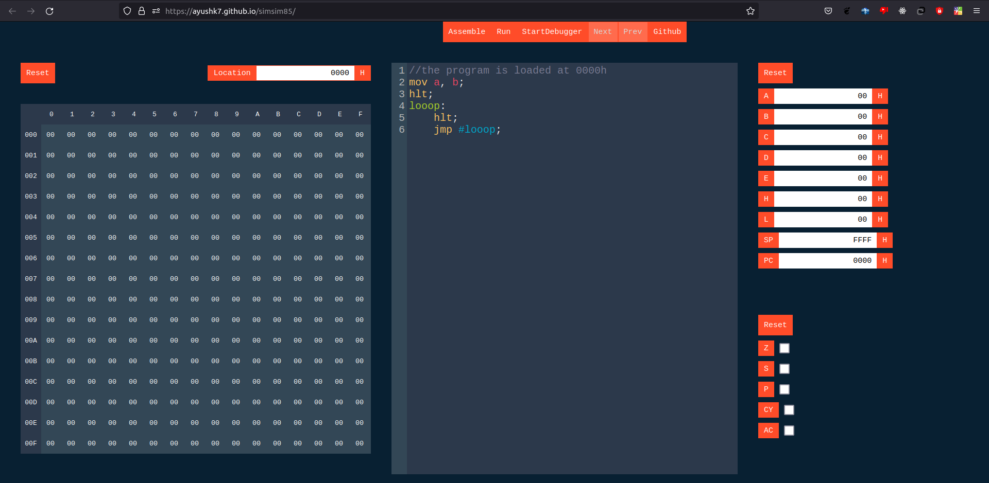
Control Bar:

Text Editor:

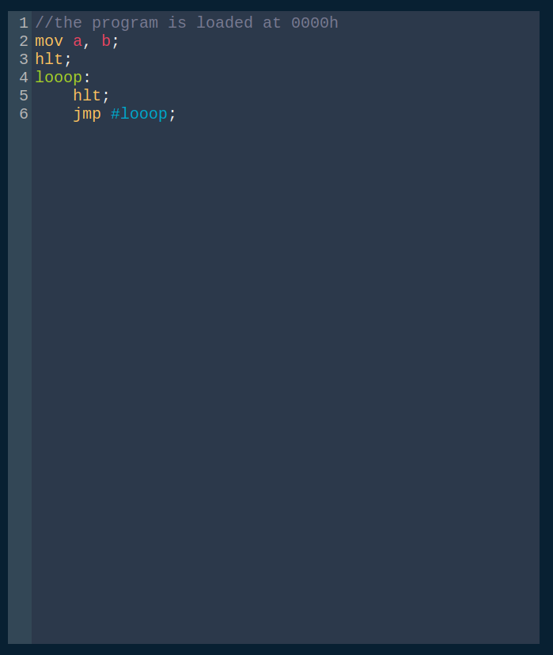

Memory Editor:
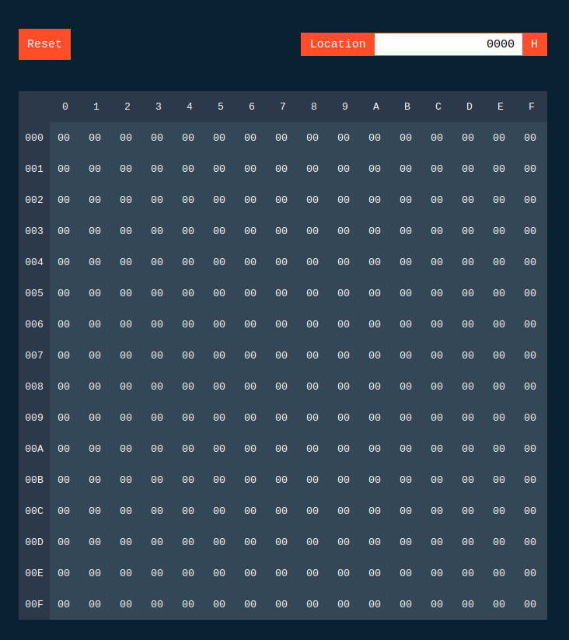

Register And Flags Editor:

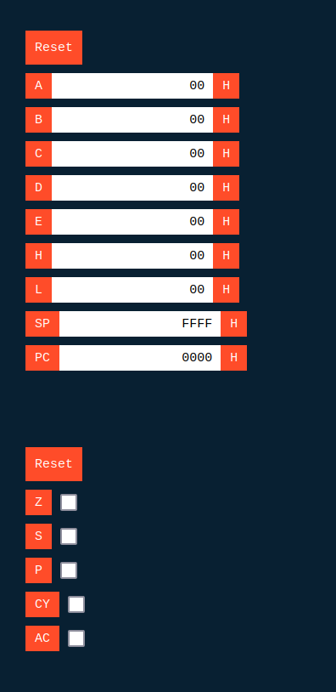

Assembled Code:

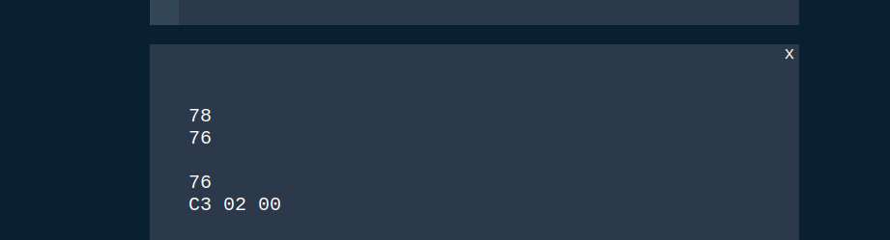

Debug Signaling:
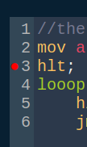

Error Signaling:
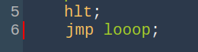

Help:
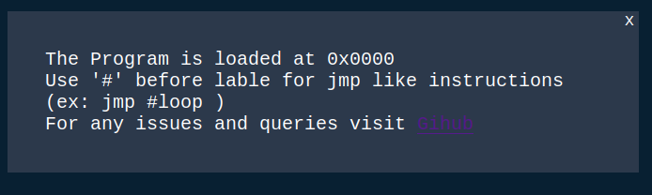

Hardware Interfaces
A PC which could run JavaScript enabled web browser is enough.

Software Interfaces
Requires JavaScript to be enabled on the user’s web browser. It requires ECMA version 6 enabled browser.

Communications Interfaces
It requires an internet connection to access the online simulator.

System Features
This section lists some of the key features of the simulator.

Modern Text Editor
- Syntax Highlighting: Custom colors for instructions, numbers, opcodes, labels, jump labels, comments
- Auto Indentation: Auto indents for label bodies

Inspect Memory and Register Status
- Inspect the status of memory , registers and the flags.
- Edit the status of memory, registers and the flags.

Assembler
- Assembles the assembly code.

Runner
- Runs the assembly output
- Updates the status of registers, memory and the flags.

Debugger
- Debug the program by running it step by step.

Other Nonfunctional Requirements

Performance Requirements
Requires modern web browser which can support ECMA script version 6.

Safety Requirements
Users can raise/report any issues/bugs they have encountered on the GitHub so that the developer can fix it.

Security Requirements
Requires modern web browser which can support ECMA script version 6.

Software Quality Attributes
Simulator can be used by both teachers and students.
However, users must already have a basic knowledge of Intel 8085 and assembly language before using it.

Appendix A: Glossary
- ECMA: European Computer Manufacturer's Association.
- ES6: ECMA script version 6 (JavaScript)
- Intel 8085: The Intel 8085 is an 8-bit microprocessor produced by Intel and introduced in March 1976.
- Registers: A processor register is a quickly accessible location available to a computer's processor.
- Flags: The FLAGS register is the status register that contains the current state of a CPU.
- RAM: Random Access Memory.
- Assembler: It is a program which converts assembly code to the binary.
- Debugger: It used to detect the logical errors in the program while executing it step by step.

